**Computer Organization And Architecture**

**S Abhishek**

**AM.EN.U4CSE19147**

**1. Using shift operation get 28 using with input 5 and 2. (Hint: sll)**

.data

prompt1: .asciiz "Enter the Number 1 (5) : "

prompt2: .asciiz "Enter the Number 2 (2) : "

result: .asciiz "The Result of Left Shift Operation is : "

.text

.globl main

main:

addi $v0,$0,4

la $a0,prompt1

syscall

addi $v0,$0,5

syscall

add $8,$0,$v0

addi $v0,$0,4

la $a0,prompt2

syscall

addi $v0,$0,5

syscall

add $9,$0,$v0

add $8,$8,$9

sll $9,$8,2

addi $v0,$0,4

la $a0,result

syscall

addi $v0,$0,1

add $a0,$0,$9

syscall

exit:

ori $v0,$0,10

syscall

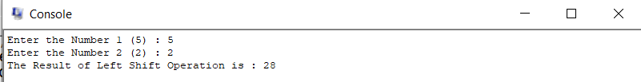

**2. Using arithmetic operation get 1 using 5 and 2. (Hint: srl)**

.data

prompt1: .asciiz "Enter the Number 1 (5) : "

prompt2: .asciiz "Enter the Number 2 (2) : "

result: .asciiz "The Result of Right Shift Operation is : "

.text

.globl main

main:

addi $v0,$0,4

la $a0,prompt1

syscall

addi $v0,$0,5

syscall

add $8,$0,$v0

addi $v0,$0,4

la $a0,prompt2

syscall

addi $v0,$0,5

syscall

add $9,$0,$v0

srl $10,$9,1

sub $8,$8,$10

srl $9,$8,2

addi $v0,$0,4

la $a0,result

syscall

addi $v0,$0,1

add $a0,$0,$9

syscall

exit:

ori $v0,$0,10

syscall

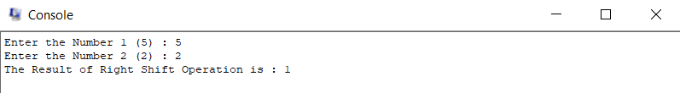

**3. Find the cost of 16 apples if once costs 8 rupees, without using any arithmetic operation?**

.data

prompt1: .asciiz "Enter the Cost of 1 Apple : "

prompt2: .asciiz "Enter the Number of Apples (n) = (16) : "

result: .asciiz "The Cost of (n = 16) Apples is : "

.text

.globl main

main:

addi $v0,$0,4

la $a0,prompt1

syscall

addi $v0,$0,5

syscall

add $8,$0,$v0

addi $v0,$0,4

la $a0,prompt2

syscall

addi $v0,$0,5

syscall

add $9,$0,$v0

sll $9,$8,4

addi $v0,$0,4

la $a0,result

syscall

addi $v0,$0,1

add $a0,$0,$9

syscall

exit:

ori $v0,$0,10

syscall

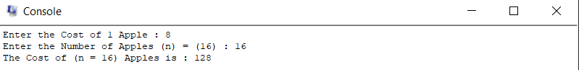

**4. Find the quotient when 128 is divided by 8, without using arithmetic operation?**

.data

prompt1: .asciiz "Enter the Number 1 (128) : "

prompt2: .asciiz "Enter the Number 2 (8) : "

result: .asciiz "The Quotient of the Division is : "

.text

.globl main

main:

addi $v0,$0,4

la $a0,prompt1

syscall

addi $v0,$0,5

syscall

add $8,$0,$v0

addi $v0,$0,4

la $a0,prompt2

syscall

addi $v0,$0,5

syscall

add $9,$0,$v0

srl $9,$8,3

addi $v0,$0,4

la $a0,result

syscall

addi $v0,$0,1

add $a0,$0,$9

syscall

exit:

ori $v0,$0,10

syscall

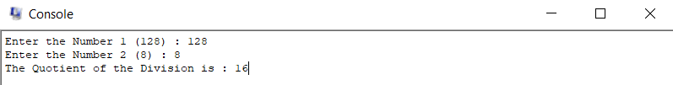

**5. Solve the linear equation using MIPS code without using mult and div. 2a+b = 4, a+4b = 9 (Note: No repeated addition or subtraction)**

.data

prompt1: .asciiz "Enter A of Equation 1 : "

prompt2: .asciiz "Enter B of Equation 1 : "

prompt3: .asciiz "Enter C of Equation 1 : "

prompt4: .asciiz "Enter A of Equation 2 : "

prompt5: .asciiz "Enter B of Equation 2 : "

prompt6: .asciiz "Enter C of Equation 2 : "

prompt7: .asciiz "\nA = "

prompt8: .asciiz "\nB = "

.text

.globl main

main:

addi $v0,$0,4

la $a0,prompt1

syscall

addi $v0,$0,5

syscall

add $8,$0,$v0

addi $v0,$0,4

la $a0,prompt2

syscall

addi $v0,$0,5

syscall

add $9,$0,$v0

addi $v0,$0,4

la $a0,prompt3

syscall

addi $v0,$0,5

syscall

add $10,$0,$v0

addi $v0,$0,4

la $a0,prompt4

syscall

addi $v0,$0,5

syscall

add $11,$0,$v0

addi $v0,$0,4

la $a0,prompt5

syscall

addi $v0,$0,5

syscall

add $12,$0,$v0

addi $v0,$0,4

la $a0,prompt6

syscall

addi $v0,$0,5

syscall

add $13,$0,$v0

add $14,$0,$13

sll $13,$13,1

srl $10,$10,2

sll $10,$10,1

sll $11,$10,2

sub $14,$14,$11

addi $v0,$0,4

la $a0,prompt7

syscall

addi $v0,$0,1

add $a0,$0,$14

syscall

addi $v0,$0,4

la $a0,prompt8

syscall

addi $v0,$0,1

add $a0,$0,$10

syscall

exit:

ori $v0,$0,10

syscall

